**NIRMA UNIVERSITY**

**INSTITUE OF TECHNOLOGY**

**MECHANICAL ENGINEERING**

**Programmable logic controller (PLC)**

**LAB – 7**

**19BME134**

**Shrey Shah**

**Aim**

PLC Programming for Automation and Industrial Control Applications – I

**Objectives**

To implement different industrial process on off control applications with PLC

**Theory**

The action of the control response can be summarized as follows:

* The output turns on when the temperature falls below the set-point and turns off when the temperature reaches the set-point.
* Control is simple, but overshoot and cycling about the set-point can be disadvantageous in some processes.
* The measured variable will oscillate around the set-point at an amplitude and frequency that depend on the capacity and time response of the process.
* Oscillations may be reduced in amplitude by increasing the sensitivity of the controller. This increase will cause the controller to turn on and off more often, a possibly undesirable result.
* On/off control is used when a more precise control is unnecessary. Ability to communicate with computer.

**Question 1**

1. Design a system to control water level in a storage tank. The process is shown in figure 1.

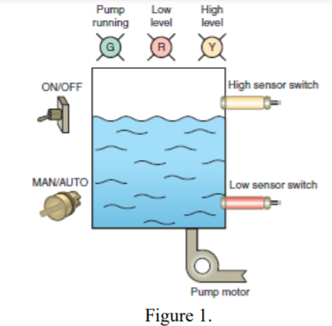

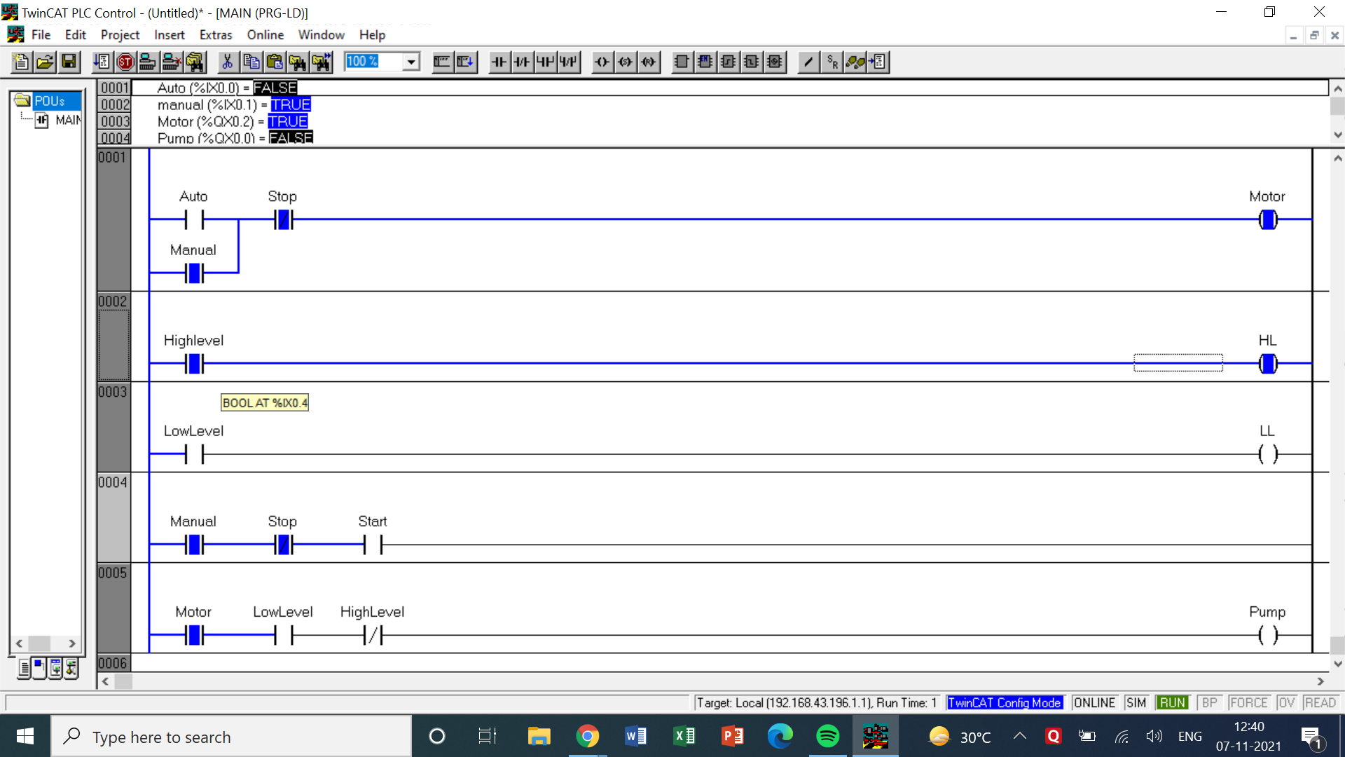

LOGIC -

* The operator has been given 2 options from the start – either do it manually or automated.
* If the manual option is selected then the user will have to manually see and turn on the water level low and water level high switches.
* If the Auto option is selected then the sensors that are kept near the tank will update the status of the water level
* After either of those, 2 switches are places in 2 rungs for High and Low water levels which turn on and off the motor when they are pressed along with the respective indication light.
* This process will continue till the stop switch is turned on.

|  |  |  |  |
| --- | --- | --- | --- |
| INPUT | | OUTPUT | |
| Auto | %ix0.0 | Motor | %qx0.0 |
| Manual | %ix0.1 | Pump | %qx0.1 |
| Stop | %ix0.2 | HL | %qx0.2 |
| Start | %ix0.3 | LL | %qx0.3 |
| High Level | %ix0.4 | - | - |
| Low Level | %ix0.5 | - | - |

1. Design a PLC ladder logic for drilling process that requires the drill press to turn on only if there is a part present and the operator has one hand on each of the start switches. The process is shown in figure 2.

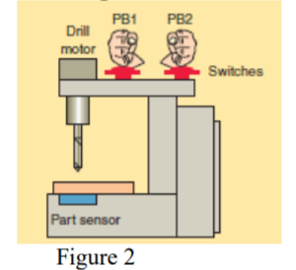

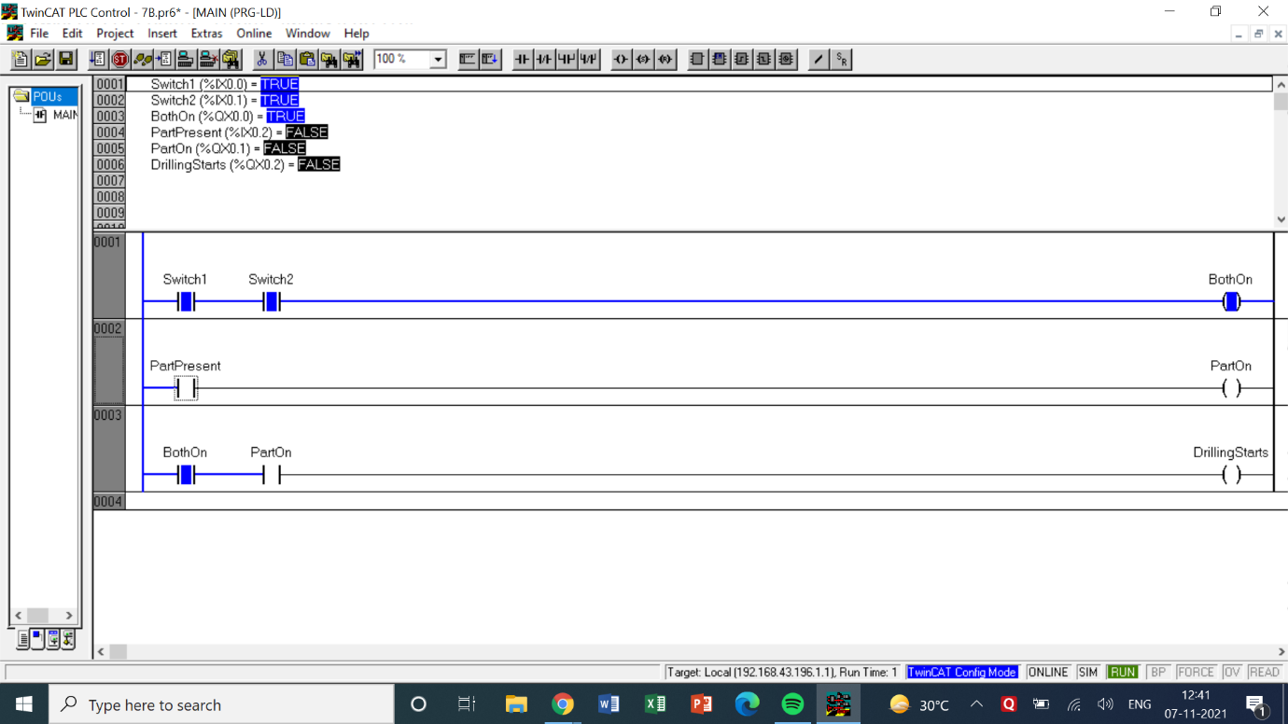

LOGIC

* The logic in this question is pretty simple. In the 1st rung, there are 2 input switches will take the position of the 2 pushbuttons. Only when both the pushbuttons are turned on will the output both on will be turned on.
* A sensor is placed in real time which will detect the part if it is placed below the drilling machine.
* If the part is present the output of part present will be turned on.
* In the 3rd rung both the outputs are connected in series so that only when both of them are turned on will the drilling will start.

|  |  |  |  |
| --- | --- | --- | --- |
| INPUT | | OUTPUT | |
| Switch 1 | %ix0.0 | Both On | %qx0.0 |
| Switch 2 | %ix0.1 | Part On | %qx0.1 |
| Part Present | %ix0.2 | Drilling Starts | %qx0.2 |

COMMENTS –

* The counters in most of the questions are denoted by the letter ‘C’ followed by the number of the counter or the letter.
* In case of UP and DOWN timers their names have been specified while mentioning the use of counters. Cn.q represents the output of those counters which may be taken as NO or NC switches.
* Each question has a table of inputs and outputs which specifies which I/Os have been taken along with its addresses.
* All the timers are generally denoted by the symbol ‘tn’ where n represents the number of the timer.
* tn.q represents the output of the timer tn which can be both normally open or normally closed depending on how it is used based on the question’s requirements.